1.
What is a Computer?
A computer is an electronic device that processes data, performs calculations, and executes instructions to complete various tasks. It takes input, processes it according to a set of instructions (software), and produces output. Computers are used in a wide range of fields, including education, business, healthcare, and entertainment.

Types of Computers
Computers come in different types based on size, processing power, and purpose. The main types include:
- Supercomputers
  - The most powerful and expensive computers.
  - Used for complex simulations, scientific research, weather forecasting, and nuclear research.
  - Example: Summit (developed by IBM).
- Mainframe Computers
  - Large and powerful systems used by large organizations for bulk data processing.
  - Used in banking, government agencies, and airline reservations.
  - Example: IBM Z series.
- Minicomputers (Mid-range Computers)
  - Less powerful than mainframes but used for business applications and industrial control systems.
  - Example: PDP-11, VAX.
- Microcomputers (Personal Computers - PCs)
  - The most common type, used for general purposes like browsing, gaming, and office work.
  - Examples: Desktop computers, laptops, tablets.
- Workstations
  - High-performance computers designed for technical and scientific applications.
  - Used by engineers, designers, and researchers.
  - Example: HP Z series, Dell Precision.
- Embedded Computers
  - Small, specialized computers built into other devices.
  - Found in cars, home appliances, medical devices, and industrial machines.
  - Example: Microcontrollers in washing machines and smart TVs.
- Servers
  - Computers that provide data, resources, and services to other computers (clients).
  - Used in networking, cloud computing, and web hosting.
  - Example: Web servers, database servers.
2.
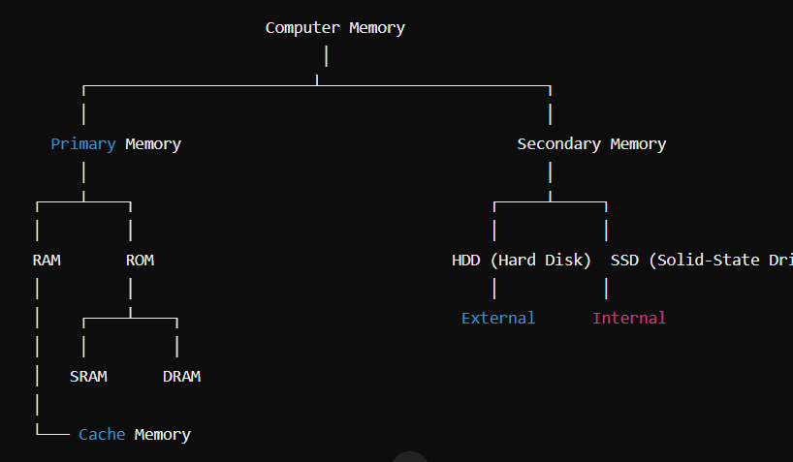
3.
Computer Input and Output Devices
A computer input device is hardware used to send data and control signals to a computer, while an output device receives and displays or processes information from the computer.

1. Input Devices
These devices allow users to enter data into a computer.
Common Input Devices:
- Keyboard – Used for typing text and commands.
- Mouse – A pointing device used to navigate and select items.
- Scanner – Converts physical documents into digital format.
- Joystick – Used for gaming and simulation control.
- Microphone – Captures sound and voice input.
- Webcam – Captures video and images for communication.
- Touchscreen – A display that acts as both an input and output device.
2. Output Devices
These devices receive and display or process information from the computer.
Common Output Devices:
- Monitor – Displays visual output from the computer.
- Printer – Produces physical copies of digital documents.
- Speakers – Outputs sound and audio.
- Projector – Displays content on a larger screen.
- Headphones – Provides private audio output.
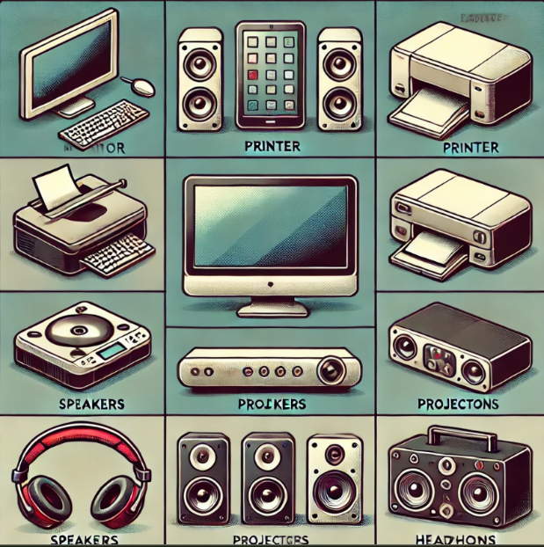
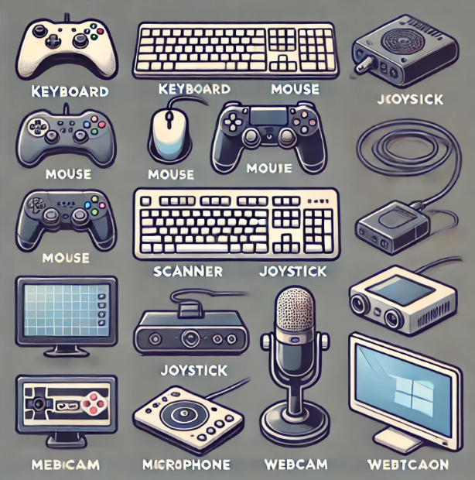
Image of Output Devices:

